GitHub Student Developer Pack

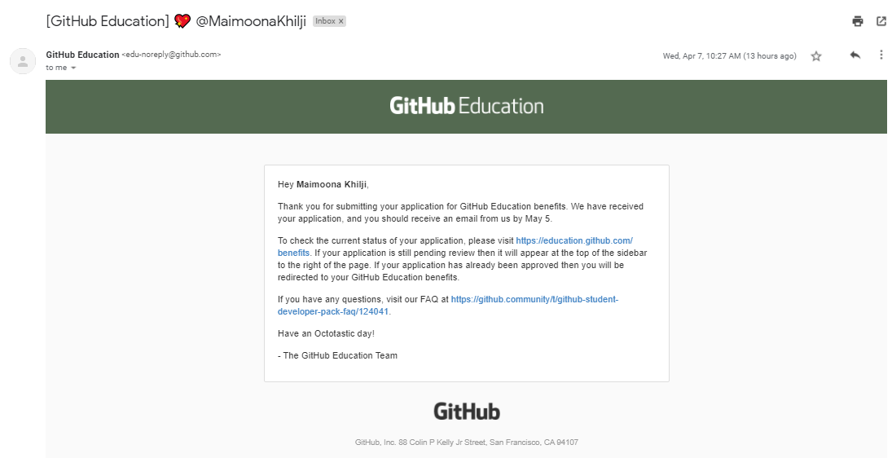

**Write a short summary on benefits of this student developer pack for a Data Science Student?**

Student developer pack is providing free access to thousands of developer tools and courses. Being a data science student, we are familiar to the importance of developing tools. All the data operations including data storage, exploration, analysis, modelling, visualization, decision making and many other data processes are done through tools. In other words, these tools ease the complexity of work. However, most of the data tools are paid. And being a student, buying these tools are pretty difficult. But Github student developer pack give students free access to different tools in one platform. It will help the students to learn and practice at the same time.

The basic benefit of Student pack is access to unlimited private repositories. Github repositories make our life easy. We can save our projects or practice our codes on github and then make repository of that code. After making repository, we will be able to access these github repositories from any place, we don’t have to keep USB.